National School of Business Management
LAB Sheet 08
Lab 08 3 layer classic CISCO design with RIP and redundant links
Set up the following scenario on Packet tracer/physical
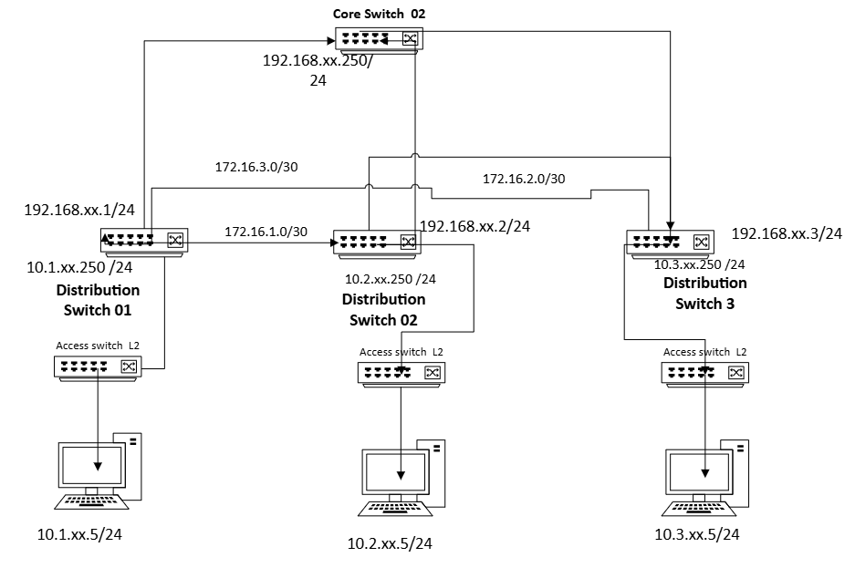

Note: - please use the LAB 07 setup as the base and implement the above for the case study given using the classical 3 tier network model
Step1. Complete the full implementation of lab 7
Implement the network model given on lab 07
Step 2. Identify the uplink ports connecting the distribution switchers
- Identify the ethernet ports you are going to use for connecting the PC and the Switch /s.
Step3 Assign IP
- Assign an Interface IP to the relevant ports/logical interfaces and Ethernet card of the computers

Step4 Testing basic connectivity and RIP behavior
- Use the basic ICMP command and rout prints to identify the routing with redundant links .
- Disable the uplink from the distribution to core
- Use the basic ICMP command and rout prints to identify the routing with redundant links
- Check both routs and routing table and verify the rip is working properly.

You may use the following commands to carry out the task

No | Disruption | Command
01 | IP address for the interface | Ip Address x.x.x.x y.y.y.y
02 | Enable RIP | Router(config)# router rip
03 | Specify Version | Router(config-router)# version 2
04 | Advertise Networks | Router(config-router)# network [network]
05 | Disable Auto-Summary | Router(config-router)# no auto-summary
06 | Verify | show ip route / show ip protocols

